Nut Android SDK Document

Revision：

Time Version mark

|  |  |  |
| --- | --- | --- |
| 2016/12/29 | 1.0 | Init |
|  |  |  |

#### Development guide

1. Development environment

Recommend Android Studio 2.0 or up；Android OS 4.3 or up。

1. Configuration manifest and input openId and appSecret

1、Manifest configuration includes the addition of permissions, the following permissions are indispensable, fill openId and appSecret, the code example is as follows:

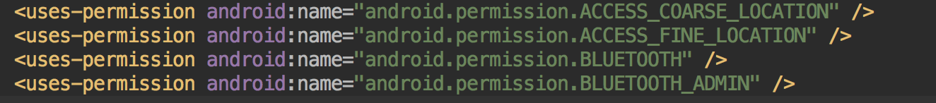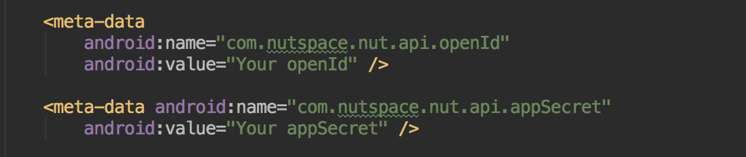

Permission description：

|  |  |
| --- | --- |
| Permission | Use |
| ACCESS_COARSE_LOCATION | Scan Nut |
| ACCESS_FINE_LOCATION | Scan Nut |
| BLUETOOTH | BLE |
| BLUETOOTH_ADMIN | BLE |

2、Configuration BleService

In the manifest definition BleService, the code example is as follows: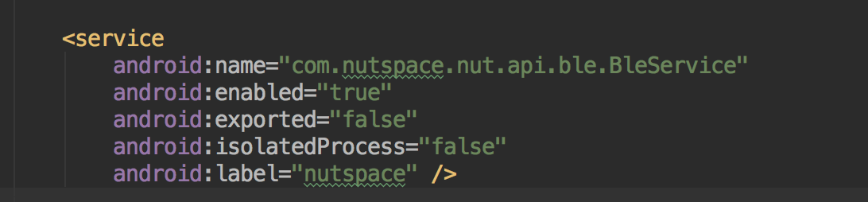

3、Import and use the SDK

3.1、Import the SDK jar package into the project, for example:

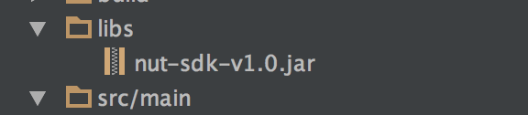

3.2、Initialize BleManager in the component (Activity or Service) and bind BleService.

The code example is as follows:

Initialization BleManager：



Bind BleService：

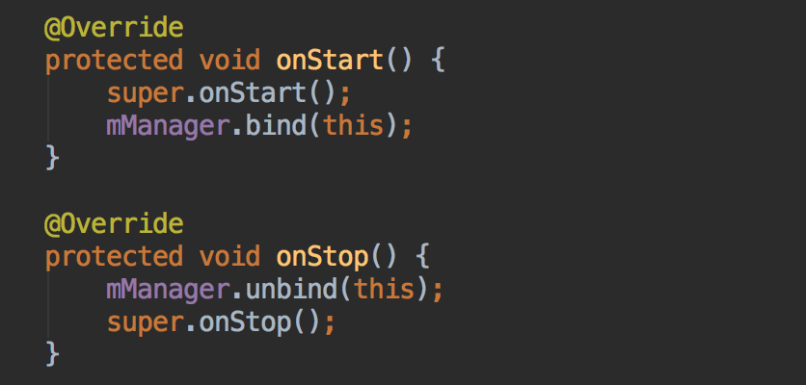

Note: The bind bind () and unbind () methods must appear in pairs

After the binding is successful callback method: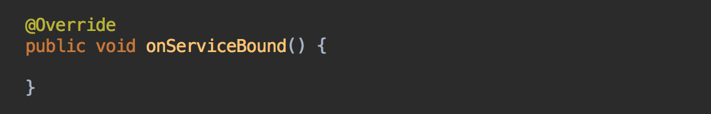

After the binding is successful, you can use the SDK by calling the object mManager.

3.3、Function used to scan as an example:

Register the scan callback interface ScanResultCallback,

the code example is as follows: 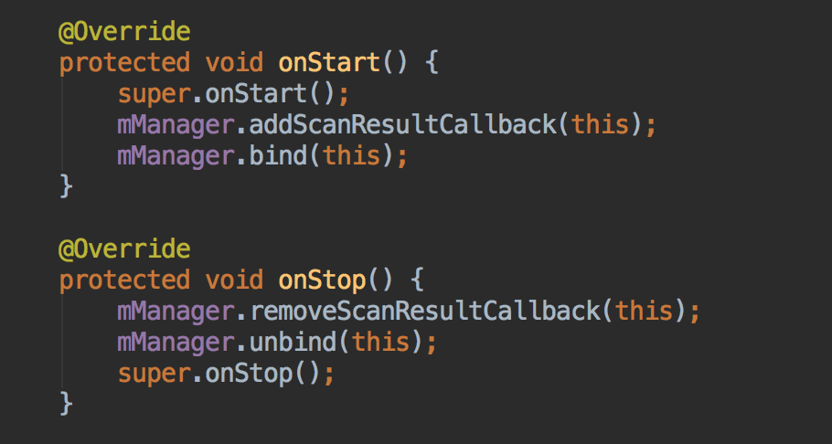

Note: You can call the removeScanResultCallback () method to remove a listening event when you do not need to listen for a scan event

Scan to device after the callback method: 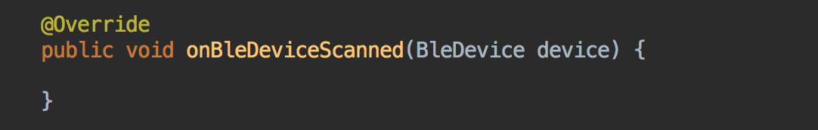

And returns the object of class BleDevice that contains the device information.

Other functions use the same as above.

4、Interface introduction：

|  |  |
| --- | --- |
| Interface | Features |
| ScanResultCallback | Monitor the results of the scanning device |
| EventCallback | Monitor rssi value changes, call device, device key count, battery changes |
| ConnectStateChangedCallback | Listen to device connection status |

The code snippet in the document is available in the SDK Demo